**RhythmicTunes: Your Melodic Companion**

**Ideation Phase**

**Define the Problem Statements**

|  |  |
| --- | --- |
| Date | 5 March 2025 |
| Team ID | Team-159103 |
| Project Name | Rhythmic Tunes |
| Maximum Marks | 2 Marks |

**Team Members Details:**

|  |  |
| --- | --- |
| **Team Members Name** | **Email id** |
| Katheeja Barvin M **(Leader)** | [katheejabarvin15@gmail.com](mailto:katheejabarvin15@gmail.com) |
| Mohanapriya G | [mo11hanapriya11@gmail.com](mailto:mo11hanapriya11@gmail.com) |
| Vasanthasena V | [vasanthasena2005@gmail.com](mailto:vasanthasena2005@gmail.com) |
| Uma Mageshwari M | [muma07084@gmail.com](mailto:muma07084@gmail.com) |

**Customer Problem Statement Template:**

Create a problem statement to understand your customer's point of view. The Customer Problem Statement template helps you focus on what matters to create experiences people will love.

A well-articulated customer problem statement allows you and your team to find the ideal solution for the challenges your customers face. Throughout the process, you’ll also be able to empathize with your customers, which helps you better understand how they perceive your product or service.

Reference: <https://miro.com/templates/customer-problem-statement/>

**Example:**

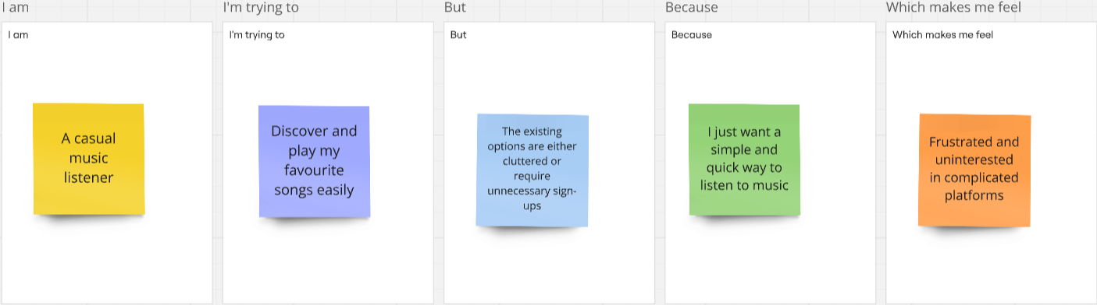

|  |  |  |  |  |  |
| --- | --- | --- | --- | --- | --- |
| Problem Statement (PS) | I am (Customer) | I’m trying to | But | Because | Which makes me feel |
| PS-1 | A casual music listener | Discover and play my favourite songs easily | The existing options are either cluttered or require unnecessary sign-ups | I just want a simple and quick way to listen to music | Frustrated and uninterested in complicated platforms |
| PS-2 | A user exploring new music | Find new songs based on my preferences | Most platforms push mainstream tracks rather than personalized recommendations | I prefer fresh, unique music rather than what’s always trending | Disconnected from my personal taste and less excited about using the platform |
| PS-3 | A multitasker | Listen to music while working or studying | The platform has interruptions like ads or buffering issues | I need a seamless experience without distractions | Annoyed and frustrated with constant disruptions |
| PS-4 | A mobile user | Stream music on my phone with a smooth interface | The UI is not optimized for mobile or lacks essential features | I want a responsive and intuitive design that makes navigation easy | Frustrated and likely to switch to another app |